**Name: Anish Sharma Div: I-1**

**Roll no: I011 SAP ID: 60003220045**

**Experiment 1**

**(Linux Commands)**

**Aim**: Explore the internal commands of Linux and write shell scripts.

**Theory**:

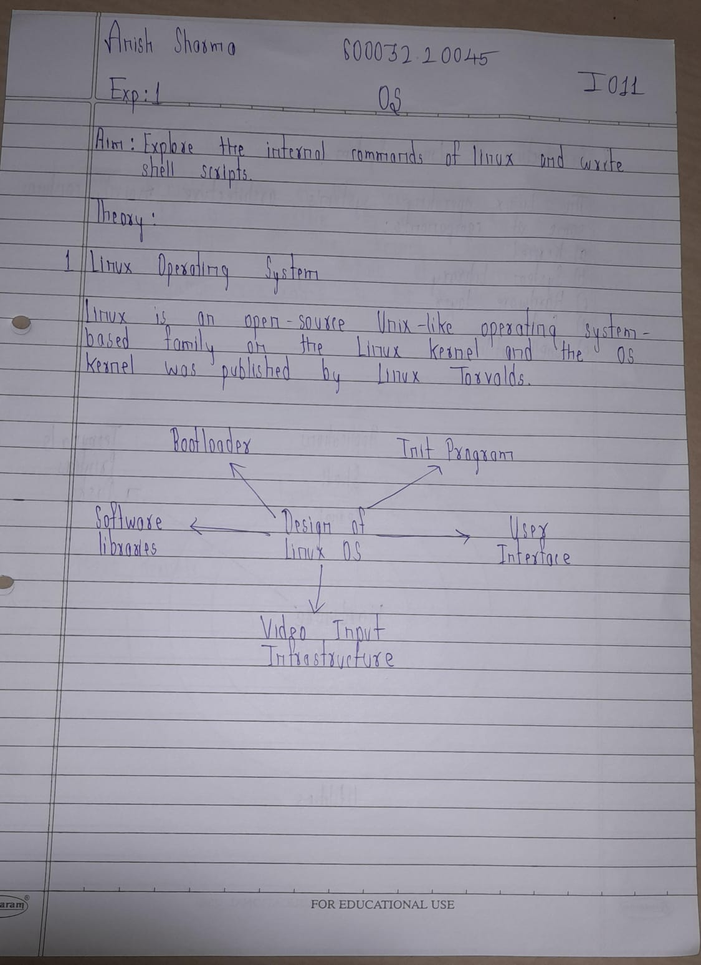

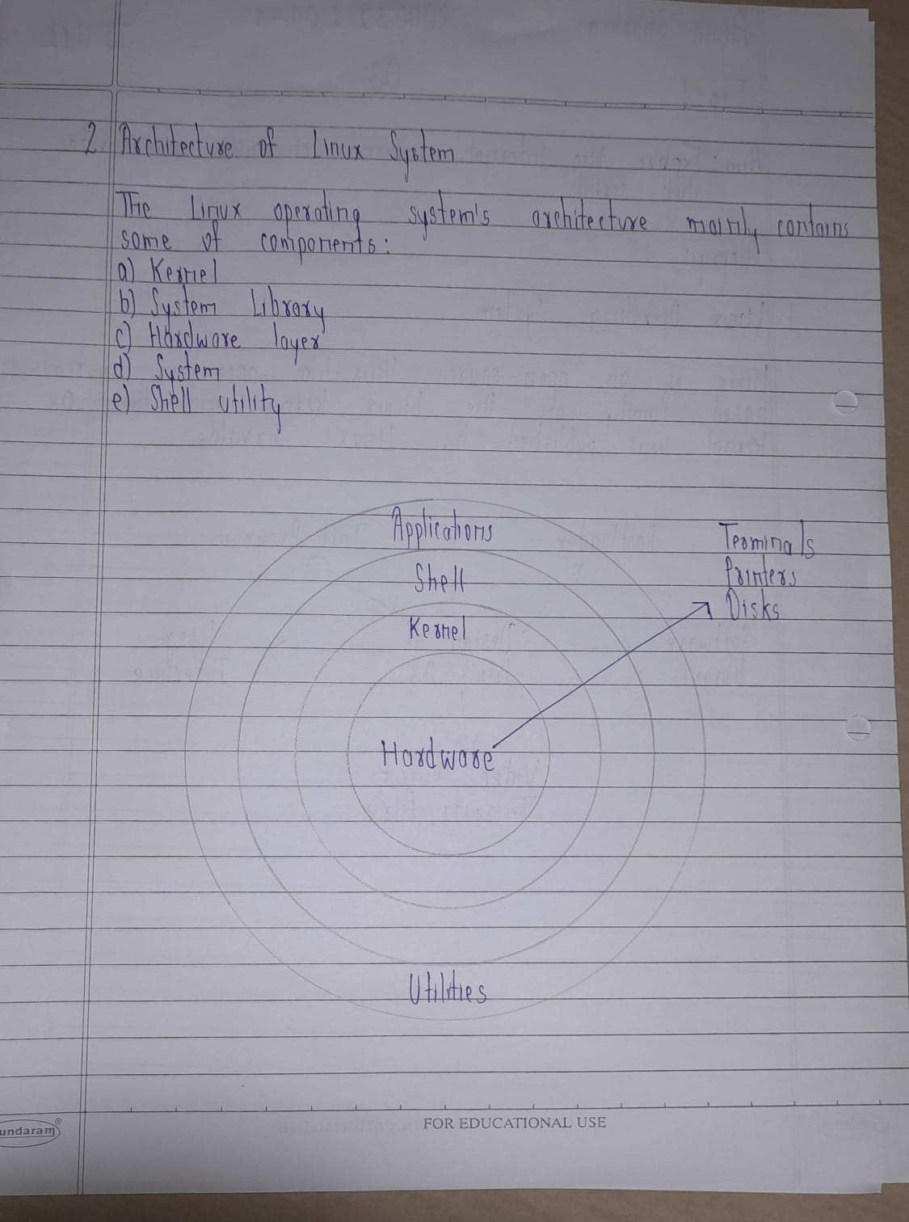

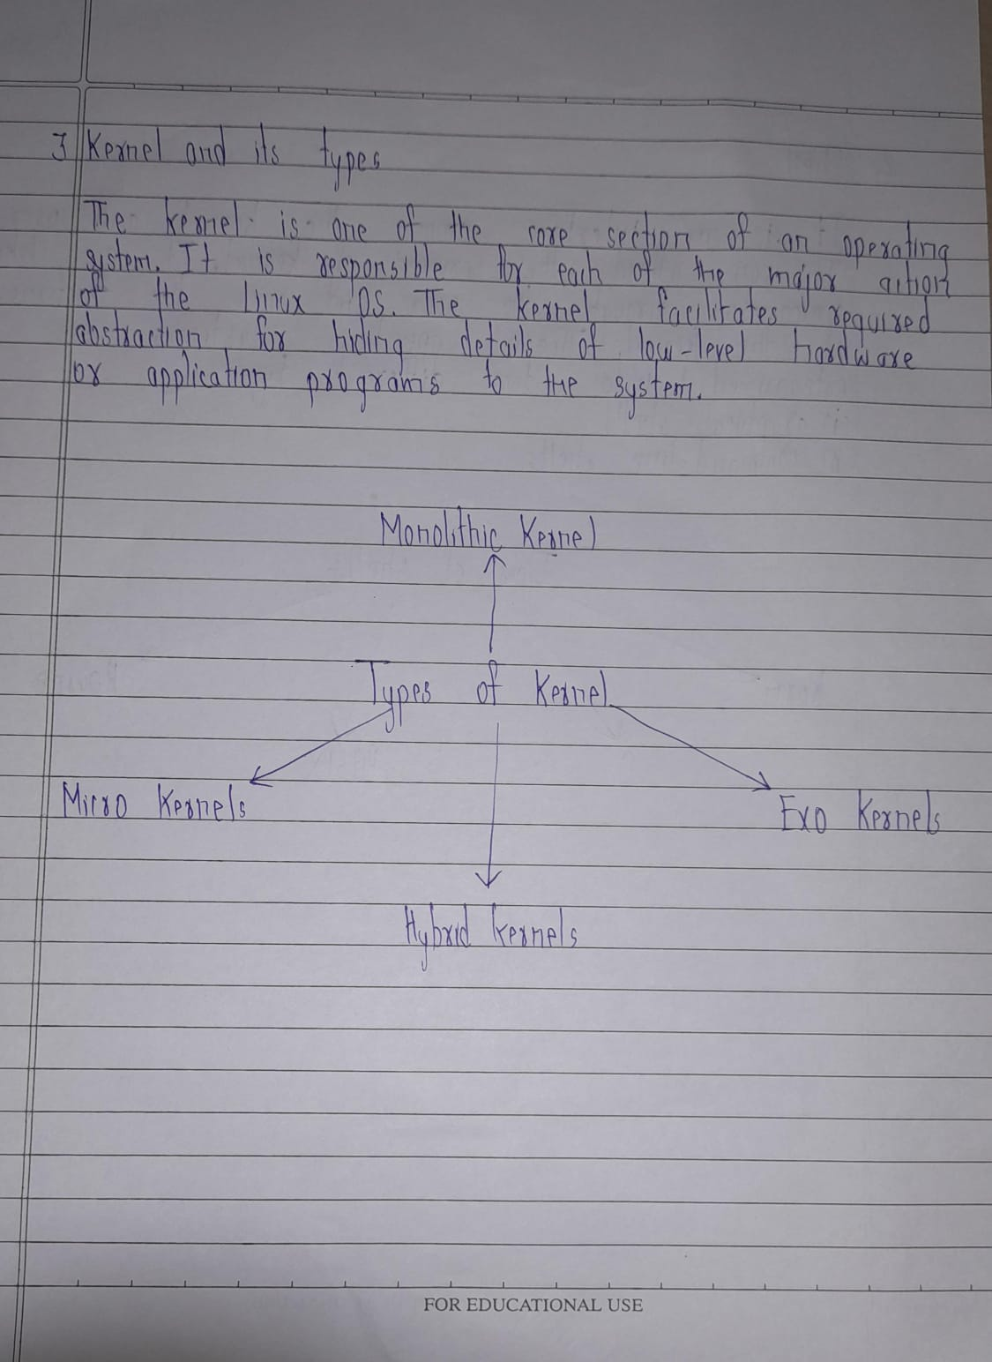

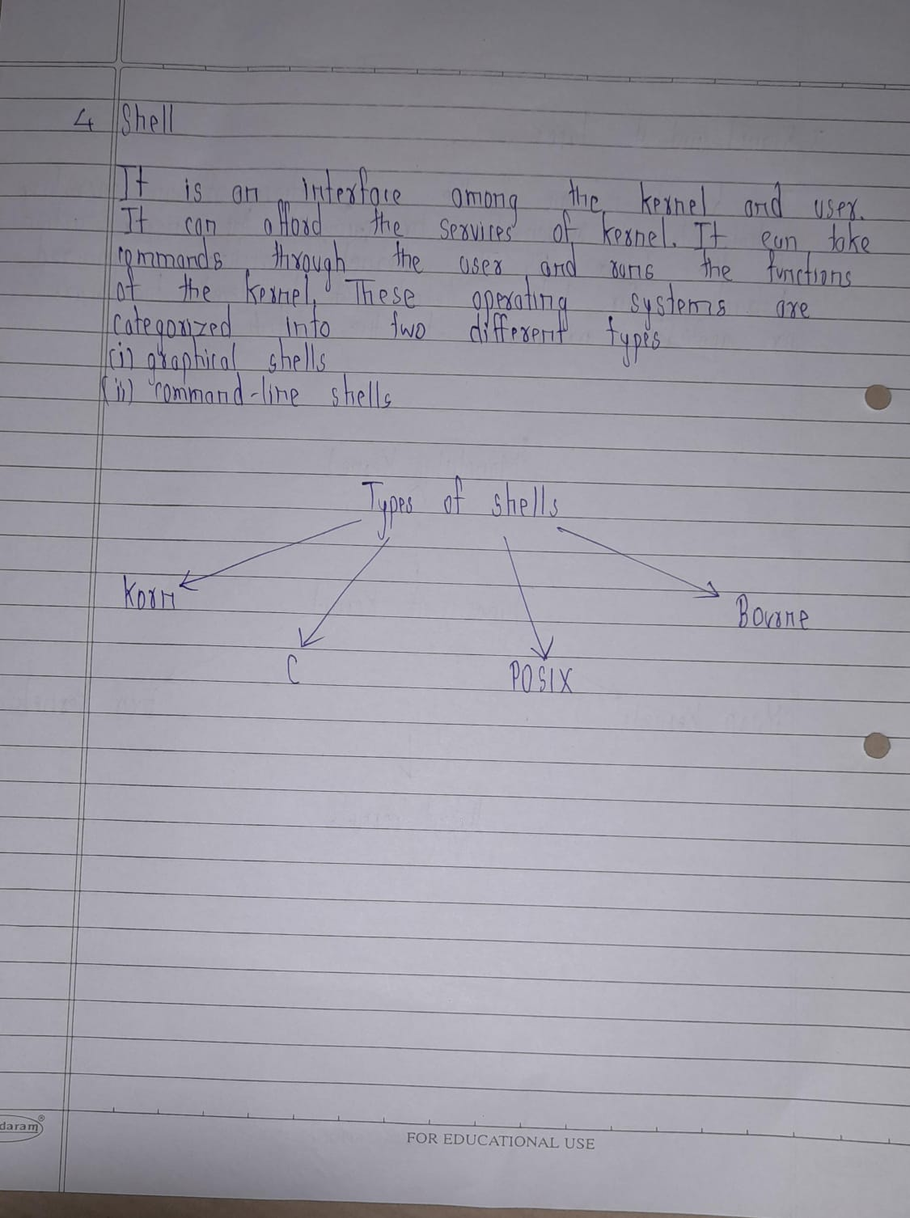

**Write theory on following points:**

* **Linux operating system**

Linux ([/ˈlɪnʊks/](https://en.wikipedia.org/wiki/Help:IPA/English) [*LIN-uuks*](https://en.wikipedia.org/wiki/Help:Pronunciation_respelling_key))  is a family of [open-source](https://en.wikipedia.org/wiki/Free_and_open-source_software) [Unix-like](https://en.wikipedia.org/wiki/Unix-like) [operating systems](https://en.wikipedia.org/wiki/Operating_system) based on the [Linux kernel](https://en.wikipedia.org/wiki/Linux_kernel), an [operating system kernel](https://en.wikipedia.org/wiki/Kernel_(operating_system)) first released on September 17, 1991, by [Linus Torvalds](https://en.wikipedia.org/wiki/Linus_Torvalds). Linux is typically [packaged](https://en.wikipedia.org/wiki/Package_manager) as a [Linux distribution](https://en.wikipedia.org/wiki/Linux_distribution) (distro), which includes the kernel and supporting [system software](https://en.wikipedia.org/wiki/System_software) and [libraries](https://en.wikipedia.org/wiki/Library_(computing)), many of which are provided by the [GNU Project](https://en.wikipedia.org/wiki/GNU_Project).

* **Architecture of Linux system**

The Linux operating system's architecture mainly contains some of the components: the Kernel, System Library, Hardware layer, System, and Shell utility.

1. Kernel:- The kernel is one of the core section of an operating system. It is responsible for each of the major actions of the Linux OS.

2. System Libraries:- These libraries can be specified as some special functions. These are applied for implementing the operating system's functionality and don't need code access rights of the modules of kernel.

3. System Utility Programs:- It is responsible for doing specialized level and individual activities.

4. Hardware layer:- Linux operating system contains a hardware layer that consists of several peripheral devices like [CPU](https://www.javatpoint.com/central-processing-unit), [HDD](https://www.javatpoint.com/hdd), and [RAM](https://www.javatpoint.com/ram).

5. Shell:- It is an interface among the kernel and user. It can afford the services of kernel. It can take commands through the user and runs the functions of the kernel.

* **Kernel and its types**

The kernel is one of the core section of an operating system. It is responsible for each of the major actions of the Linux OS. This operating system contains distinct types of modules and cooperates with underlying hardware directly. The kernel facilitates required abstraction for hiding details of low-level hardware or application programs to the system. There are some of the important kernel types which are mentioned below:

* Monolithic Kernel
* Micro kernels
* Exo kernels
* Hybrid kernels
* **Shell**

 It is an interface among the kernel and user. It can afford the services of kernel. It can take commands through the user and runs the functions of the kernel. The shell is available in distinct types of OSes. These operating systems are categorized into two different types, which are the graphical shells and command-line shells.

The graphical line shells facilitate the graphical user interface, while the command line shells facilitate the command line interface. Thus, both of these shells implement operations. However, the graphical user interface shells work slower as compared to the command-line interface shells.

**Procedure:**

**Execute following commands on terminal and include the description and snapshot of each command**

**Linux Commands**

**(I) File and Directory Related commands**

**1) pwd**

This command prints the current working directory

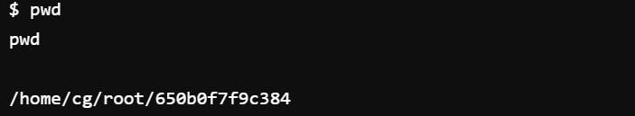

**2) ls**

This command displays the list of files in the current working directory.

$ls –l Lists the files in the long format

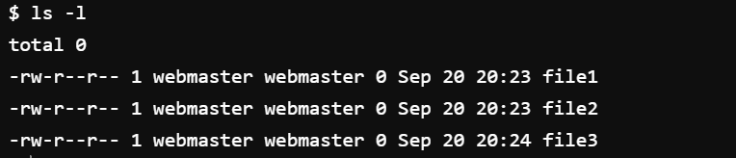

$ls –t Lists in the order of last modification time

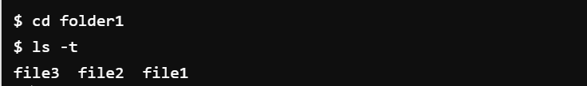

$ls –d Lists directory instead of contents

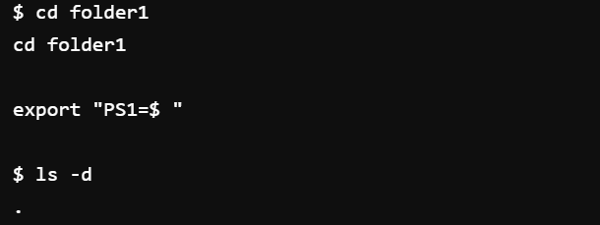

$ls -u Lists in order of last access time

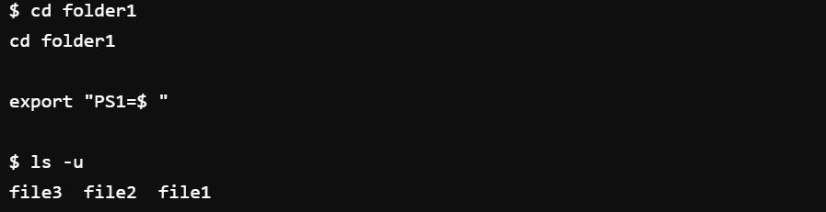

**3) cd**

This command is used to change from the working directory to any other directory specified.

$cd directoryname

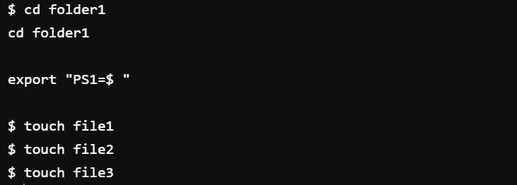

**4) cd ..**

This command is used to come out of the current working directory.

$cd ..

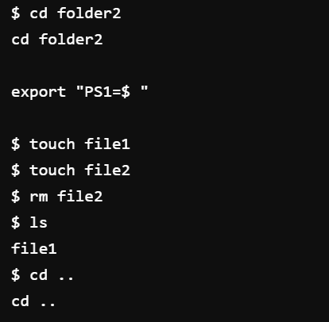

*used cd command to access the directory then cd .. command to exit it

**5) mkdir**

This command helps us to make a directory.

$mkdir directoryname

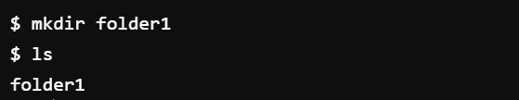

**6) rmdir**

This command is used to remove a directory specified in the command line. It requires the

specified directory to be empty before removing it.

$rmdir directoryname

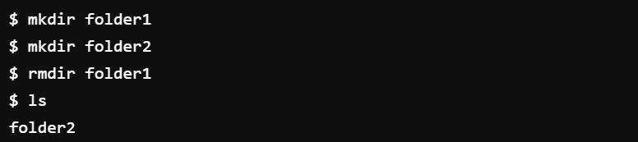

**7) cat**

This command helps us to list the contents of a file we specify.

$cat [option][file]

cat > filename – This is used to create a new file.

cat >>filename – This is used to append the contents of the file

Eg:

cat file1

cat file1 file2 > all

cat file1 >> file2

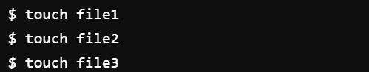

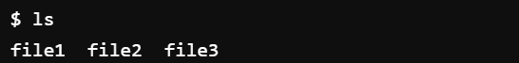

**8) cp**

This command helps us to create duplicate copies of ordinary files.

$cp source destination

**9) mv**

ss

This command is to establish an additional filename for the same ordinary file.

$ln firstname secondname

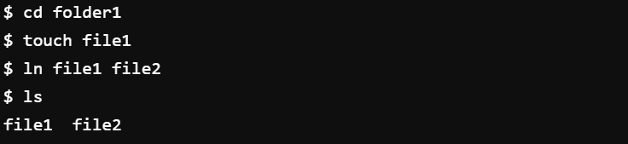

**11) rm**

This command is used to delete one or more files from the directory.

$rm [option] filename

$rm –i Asks the user if he wants to delete the file mentioned.

$rm –r Recursively delete the entire contents of the directory as well as the

directory itself.

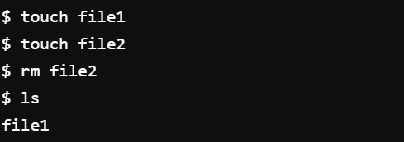

**(II) Process and status information commands**

**1) who**

This command gives the details of who all have logged in to the UNIX system currently.

$ who

*command doesn’t work in the online environment

**2) who am i**

This command tells us as to when we had logged in and the system’s name for the

connection being used.

$who am i

8

*command doesn’t work in the online environment

**3) date**

This command displays the current date in different formats.

+%D mm/dd/yy +%w Day of the week

+%H Hr-00 to 23 +%a Abbr.Weekday

+%M Min-00 to 59 +%h Abbr.Month

+%S Sec-00 to 59 +%r Time in AM/PM

+%T HH:MM:SS +%y Last two digits of the year

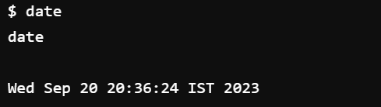

**4) echo**

This command will display the text typed from the keyboard.

$echo

Eg: $echo Have a nice day

O/p Have a nice day

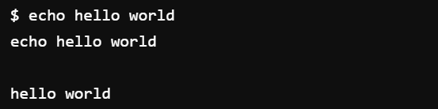

**(III)  Text related commands**

**1. head**

This command displays the initial part of the file. By default it displays first ten lines of the

file.

$head [-count] [filename]

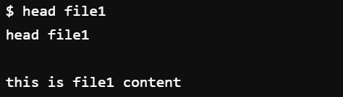

**2. tail**

This command displays the later part of the file. By default it displays last ten lines of the

file.

$tail [-count] [filename]

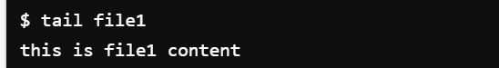

**3. wc**

This command is used to count the number of lines, words or characters in a file.

wc -l <filename> print the line count

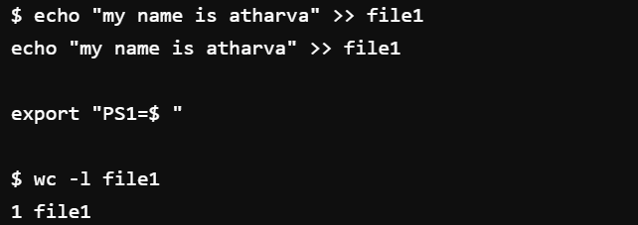

wc -c <filename> print the byte count

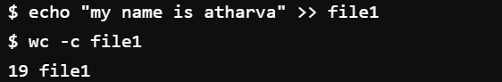

wc -m <filename> print the character count

wc -L <filename> print the length of longest line



wc -w <filename> print the word count

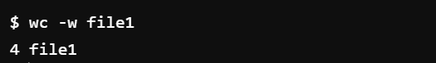

**4. find**

The find command is used to locate files in a directory and in a subdirectory.

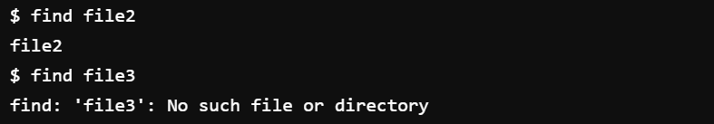

**(IV) File Permission commands**

**1) chmod**

Changes the file/directory permission mode:

$chmod [option] mode files

**options:**

-R Descend directory arguments recursively while setting modes.

-f Suppress error messages if command fails.

**mode:**

Who u=user, g=group, o=other, a=all (default)

**Opcode**

+ means add permission

— means remove permission

= means assign permission and remove the permission of unspecified fields

**Permission** r=Read, w=write, x=Execute

Eg. $ chmod 777 file1

Gives full permission to owner, group and others

$ chmod o-w file1

Removes write permission for others.

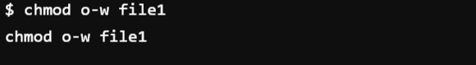

**2) chgrp**

chgrp user file      Makes file belong to the group user.

**3) chown**

chown cliff file     Makes cliff the owner of file.

chown -R cliff dir   Makes cliff the owner of dir and everything in its directory tree.

**(V) Other Useful Commands:**

**1) exit** - Ends your work on the UNIX system.

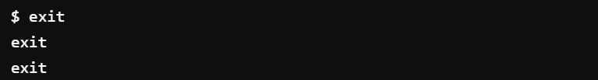

**2) Ctrl-l or clear**

Clears the screen.

Before the command

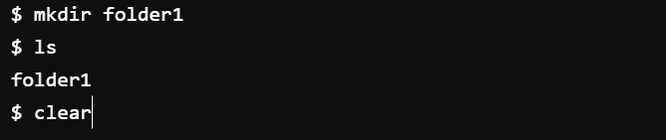

After the command



**3) Ctrl-c**

Stops the program currently running.

**4) Ctrl-z**

Pauses the currently running program.

**5) man COMMAND**

Looks up the UNIX command COMMAND in the online manual pages.

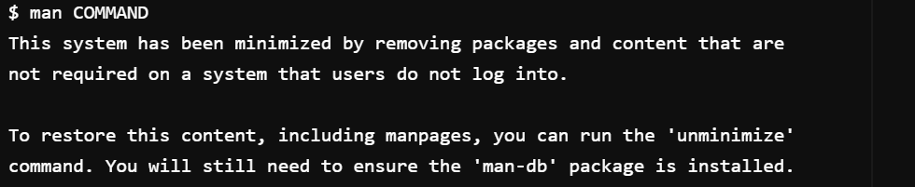

**6) history**

List all commands typed so far.

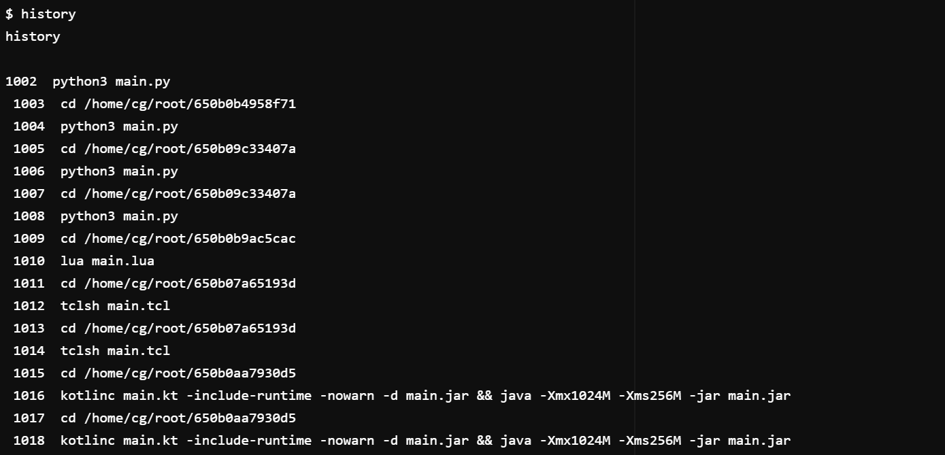

**7) more FILE**

Display the contents of FILE, pausing after each screenful.

There are several keys which control the output once a screenful has been printed.

<enter> Will advance the output one line at a time.

<space bar> Will advance the output by another full screenful.

"q" Will quit and return you to the UNIX prompt.

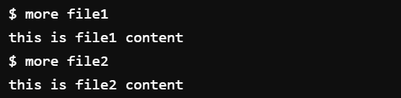

**8) less FILE**

"less" is a program similar to "more", but which allows backward movement in the file as well as forward movement.

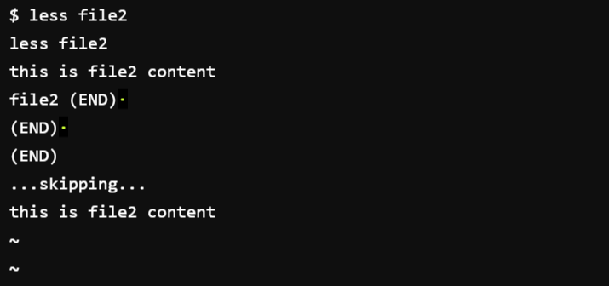

**9) lpr FILE**

The lpr command submits files for printing. Files supplied at the command-line are sent to the specified printer or to the print queue if the printer is busy.

**Shell Scripting**

A shell is a special user program that provides an interface for the user to use operating system services. Shell accepts human-readable commands from users and converts them into something which the kernel can understand. It is a command language interpreter that executes commands read from input devices such as keyboards or from files. The shell gets started when the user logs in or starts the terminal.   
**Shell is broadly classified into two categories –**

**Command Line Shell**

**Graphical shell**

**Hello.sh**

echo "What is your name?"

read PERSON

echo "Hello, $PERSON"

Here is a sample run of the script −

$./Hello.sh

**Add.sh**

val=`expr 2 + 2`

echo "Total value : $val"

**Loop in shell**

read x

read y

if [ $x -gt $y ]

then

echo X is greater than Y

elif [ $x -lt $y ]

then

echo X is less than Y

elif [ $x -eq $y ]

then

echo X is equal to Y

fi

**Conclusion:** I have learned basic Linux command.